MEDJUGORJE PILGRIMAGE
To the Immaculate Heart of Mary
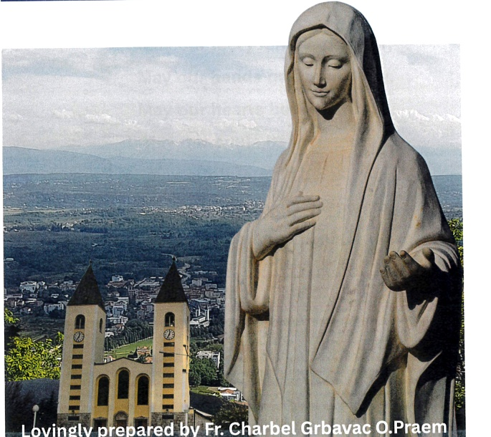
Lovingly prepared by Fr. Charbel Grbavac O.Praem
Complete illustrated pilgrim-facing draft for Father Charbel's use
Purpose of this edition
This edition preserves Father Charbel's pilgrimage material in a cleaner, more readable form for pilgrims. It keeps the devotional purpose, restores a clear order, and begins with a fuller explanation of the Mass so the pilgrimage is rooted in the Eucharist.

How to Use This Booklet
This booklet is not meant to be read like a novel. It is a prayer companion. Use it before travelling, during the pilgrimage, and afterwards when the grace of the journey begins to settle into daily life.
- Pray slowly rather than trying to finish everything.
- Use the Rosary, Divine Mercy Chaplet and Mass meditations as anchors.
- Go to Confession if possible. Pilgrimage is about conversion, not religious tourism.
- Keep difficult prayers under spiritual guidance. The sacraments and obedience to the Church come first.

Opening Prayer: The Unity Prayer
My adorable Jesus, may our feet journey together. May our hands gather in unity. May our hearts beat in unison. May our souls be in harmony. May our thoughts be as one. May our ears listen to the silence together. May our glances profoundly penetrate each other. May our lips pray together to gain mercy from the Eternal Father. Amen.

The Holy Sacrifice of the Mass
The Mass is the centre of the pilgrimage because it is the Church's highest prayer and the sacramental making-present of Christ's sacrifice. A pilgrim does not merely attend an event; he or she is drawn into the prayer of Christ to the Father through the Holy Spirit.
The Roman Rite has four visible movements: the Introductory Rites, the Liturgy of the Word, the Liturgy of the Eucharist, and the Concluding Rites. The two principal parts - Word and Eucharist - form one single act of worship.

Before Mass: preparing the altar and the heart
- The church, altar, sacred vessels, bread, wine, water, candles and vestments are prepared. The pilgrim also prepares the heart through silence, repentance and expectation.
- The priest vests for Mass. He does not act as a private individual, but as a priest of Jesus Christ, set apart for the sacred action.
- The intention of the Mass gathers the needs of the Church, the living and the dead, the sick, the suffering and all those carried in prayer by the pilgrims.

Introductory Rites: becoming one praying people
- Entrance procession: the priest and ministers approach the altar. The people gather as one body, and the pilgrimage journey is brought to the altar.
- Reverence and kiss of the altar: the altar represents Christ and the place of sacrifice. The kiss is an act of reverence and love.
- Sign of the Cross and greeting: the Mass begins in the name of the Father, and of the Son, and of the Holy Spirit. Every grace comes from God.
- Penitential Act: the faithful acknowledge sin and ask for mercy. Pilgrimage begins with conversion, not religious tourism.
- Gloria and Collect: the Church praises God, and the priest gathers the prayer of the people into one opening prayer.

Liturgy of the Word: Christ speaks to His Church
- First Reading, Psalm and Second Reading: the pilgrim listens to the history of salvation and hears God's word addressed to the present moment.
- Gospel: the people stand because Christ speaks in a special way through the Gospel.
- Homily: the priest helps the people understand and live the Word of God.
- Creed and Prayer of the Faithful: the people profess the faith and then pray for the Church, the world, the suffering and the local community.

Liturgy of the Eucharist: the sacrifice of Christ made present
- Preparation of the gifts: bread and wine, with water, are brought to the altar. Human work, suffering and gratitude are offered to God to be transformed.
- Offering prayers: the priest blesses God over the bread and wine. Creation is returned to the Creator in thanksgiving.
- Washing of hands: the priest quietly expresses the desire for inner purification before the Eucharistic Prayer.
- Prayer over the Offerings: the Church asks God to accept the gifts and make them holy and fruitful.
- Preface and Sanctus: the priest calls the people to lift up their hearts. Heaven and earth join in praise: Holy, Holy, Holy.
- Eucharistic Prayer: this is the heart of the Mass. Thanks is given to God for the whole work of salvation, and the offerings become the Body and Blood of Christ.
- Consecration: the words of Christ are spoken over the bread and wine. By the power of the Holy Spirit, Christ becomes truly present under the appearances of bread and wine.
- Memorial and offering: the Church remembers Christ's Passion, Resurrection and Ascension, and offers the sacrifice to the Father.
- Doxology and Amen: through Christ, with Christ, and in Christ, all glory is offered to the Father. The people's Amen is their full consent to the Eucharistic sacrifice.

Communion Rite: receiving the fruit of the Cross
- The Lord's Prayer: the pilgrim asks for daily bread and forgiveness.
- Sign of peace and breaking of the bread: the Church asks for peace and recognises Christ as the Lamb of God.
- Holy Communion: the properly disposed faithful receive Christ Himself. The journey becomes union with Jesus.
- Prayer after Communion: the priest asks that the sacrament may bear fruit in the lives of the faithful.

Concluding Rites: sent to live the pilgrimage
- Blessing and dismissal: the priest blesses the people and sends them out. The grace of pilgrimage is carried into ordinary life.
- The altar is reverenced again. The pilgrim leaves the church, but the Eucharistic mission continues.

Mass and the Passion of Jesus
The Mass can also be prayed as a meditation on the Passion. The priest's movement to the altar can remind us of Christ going freely to His sacrifice. The Penitential Act places us among those in need of mercy. The offering of bread and wine gathers human labour and suffering. The consecration brings us to the self-giving of Christ. Holy Communion is the fruit of the Cross received into the soul.
This way of praying does not replace the Church's liturgical meaning of the Mass. It deepens attention by connecting the visible actions of the liturgy with the saving love of Jesus.

The Shape of Salvation History
The manuscript points towards a broad Catholic pattern: grace comes from the Father through Jesus Christ, is poured out by the Holy Spirit, and is continued in the Church through Scripture, Tradition, the sacraments and the apostolic mission.
Christ | The Church | The Pilgrim
Christ is King, Priest and Prophet. | The Church teaches, sanctifies and governs in His name. | The pilgrim responds through faith, repentance and charity.
Christ offers Himself for the salvation of the world. | The sacraments bring His grace to the faithful. | The pilgrim returns to Confession, Mass and prayer.
Christ sends the Holy Spirit. | The Church prays with Mary as at Pentecost. | The pilgrim asks for the gifts of the Holy Spirit.

Father Charbel’s Teaching: The Table of Sevens
This teaching uses the number seven as a way of remembering the journey from sin to grace. It should be read as a meditation, not as a rigid mathematical system.
How to read this table
Each line begins with a spiritual obstacle and points towards a remedy: a gift of the Holy Spirit, a mystery of Mary’s suffering, a sacrament, a word of Christ from the Cross, a petition of the Our Father and a Beatitude.

Avarice / Greed
Remedy: Fear of the Lord. Marian sorrow: the prophecy of Simeon. Sacrament: Baptism. Word from the Cross: Today you will be with me in Paradise. Our Father: Thy Kingdom come. Beatitude: Blessed are the poor in spirit.
Sloth / Laziness
Remedy: Understanding. Marian sorrow: Jesus is taken down from the Cross. Sacrament: Confirmation. Word from the Cross: My God, my God, why have you forsaken me. Our Father: Thy will be done. Beatitude: Blessed are those who mourn.
Anger
Remedy: Piety / Reverence. Marian sorrow: the flight into Egypt. Sacrament: Anointing of the Sick. Word from the Cross: I thirst. Our Father: Hallowed be Thy name. Beatitude: Blessed are the meek.
Gluttony
Remedy: Fortitude / Courage. Marian sorrow: Mary meets Jesus on the way of the Cross. Sacrament: Holy Eucharist. Word from the Cross: Behold your son; behold your Mother. Our Father: Give us this day our daily bread. Beatitude: Blessed are those who hunger and thirst for righteousness.
Envy / Jealousy
Remedy: Counsel / Right Judgement. Marian sorrow: the death of Jesus on the Cross. Sacrament: Confession. Word from the Cross: Father, forgive them. Our Father: Forgive us our trespasses. Beatitude: Blessed are the merciful.
Lust
Remedy: Knowledge. Marian sorrow: finding Jesus in the Temple. Sacrament: Matrimony. Word from the Cross: It is finished. Our Father: Lead us not into temptation. Beatitude: Blessed are the pure of heart.
Pride
Remedy: Wisdom. Marian sorrow: the burial of Jesus. Sacrament: Holy Orders / Priesthood. Word from the Cross: Father, into your hands I commend my spirit. Our Father: Deliver us from evil. Beatitude: Blessed are the peacemakers.
The eighth Beatitude - blessed are those persecuted for righteousness’ sake - gathers up the whole Christian path of fidelity.

Father Charbel’s Teaching: The Table of Threes
This teaching uses groups of three to remind the pilgrim that Christian faith is Trinitarian: everything begins and ends in the Father, the Son and the Holy Spirit.
The Holy Trinity: Father, Son and Holy Spirit.
The Holy Family: St Joseph, Jesus and Mary.
The central mysteries of Christ: Incarnation, Passion and Resurrection.
The Synoptic Gospels: Matthew, Mark and Luke.
The gifts of the Magi: Gold, frankincense and myrrh.
Christ’s office: King, Priest and Prophet.
The Church’s mission: To govern, to sanctify and to teach.
The Rosary as prayer: Vocal prayer, meditation and contemplation.
The theological virtues: Faith, hope and charity.
The faculties of the soul: Intellect, memory and will.
The comings of Christ: His Incarnation, His Eucharistic coming, and His coming again in glory.
Three works of conversion: Almsgiving, prayer and fasting.

Chaplet of Divine Mercy
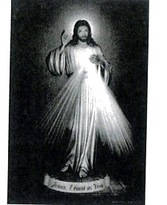
Divine Mercy image from the original pamphlet
The Chaplet of Divine Mercy is prayed on ordinary rosary beads. It is especially suited to pilgrims because it teaches trust in the mercy of Jesus.
- Begin with the Sign of the Cross.
- Pray one Our Father, one Hail Mary and the Apostles’ Creed.
- On each large bead pray: Eternal Father, I offer You the Body and Blood, Soul and Divinity of Your dearly beloved Son, Our Lord Jesus Christ, in atonement for our sins and those of the whole world.
- On each small bead pray: For the sake of His sorrowful Passion, have mercy on us and on the whole world.
- Conclude three times: Holy God, Holy Mighty One, Holy Immortal One, have mercy on us and on the whole world.
Eternal God, in whom mercy is endless and the treasury of compassion inexhaustible, look kindly upon us and increase Your mercy in us, that in difficult moments we may not despair, but submit ourselves with confidence to Your holy will, which is Love and Mercy itself. Amen.

Devotion to the Sacred Head of Our Lord
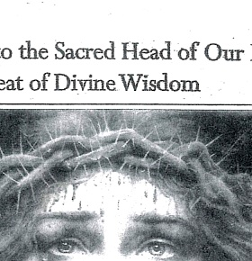
Sacred Head image from the original pamphlet
This devotion honours the Sacred Head of Jesus as the Seat of Divine Wisdom, inseparably united to His Sacred Heart. It invites the pilgrim to surrender the mind, memory, imagination and understanding to Christ.
O Seat of Divine Wisdom and guiding Power, which governs all the motions and love of the Sacred Heart, may all minds know You, all hearts love You, and all tongues praise You, now and forever. Amen.
Pray three Glory Bes in honour of the Divine Will, Memory and Understanding of Our Lord Jesus Christ.

The Holy Face of Jesus
The Holy Face devotion helps the pilgrim contemplate the suffering and love of Christ: His humiliation, wounds, silence and mercy.
Lord Jesus, through Your Holy Face, wounded for our sins and shining with mercy, heal our pride, soften our hearts and teach us to seek the face of the Father. Amen.

The Tree of Virtue
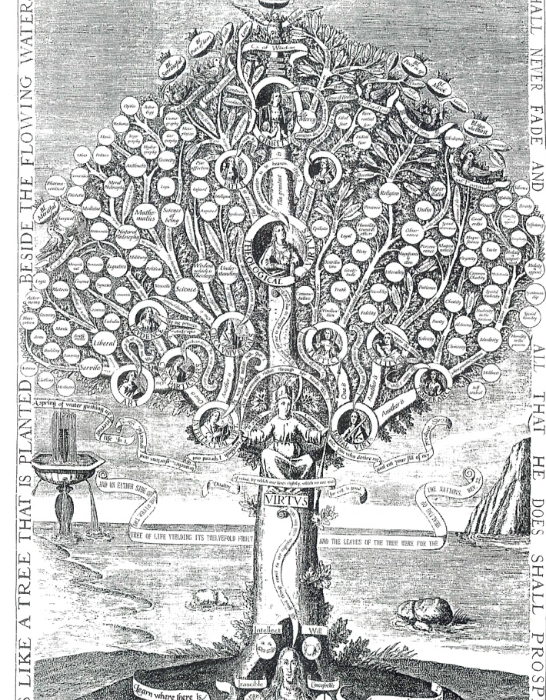
The Tree of Virtue illustration from the original pamphlet
The Tree of Virtue presents the Christian life as growth in grace. The theological virtues - faith, hope and charity - draw the soul upward towards God. The cardinal virtues - prudence, justice, fortitude and temperance - help order daily life according to reason and grace.
- Faith opens the mind to God’s truth.
- Hope anchors the soul in God’s promises.
- Charity unites us to God and neighbour in love.
- Prudence, justice, fortitude and temperance make virtue practical in ordinary choices.

The Rosary on Pilgrimage
The Rosary is a school of prayer. It places the pilgrim beside Mary and teaches the heart to contemplate the mysteries of Christ: joyful, luminous, sorrowful and glorious.
Pray slowly. Do not race through the beads. Let each decade become a step with Our Lady towards Jesus.

Novena to the Holy Spirit
The handwritten notes in the original manuscript connect the Novena to the Holy Spirit with the Upper Room. Before Pentecost, Mary and the Apostles prayed together, waiting for the coming of the Advocate, the Paraclete.
A pilgrim can pray this novena before travelling, asking the Holy Spirit for wisdom, understanding, counsel, fortitude, knowledge, piety and fear of the Lord.

Prayers for Healing and Protection
These prayers should be prayed with humility and trust. They are not a substitute for Confession, the Eucharist, spiritual direction, counselling or medical care. They are prayers to Christ, who heals and protects His people.

Prayer for Healing
Lord Jesus, You came to heal wounded and troubled hearts. I ask You to heal the wounds that cause anxiety, fear and sin in my life. Enter my heart, restore what is broken, and lead me into peace, trust and love. Amen.

Prayer for Inner Healing
Heavenly Father, let Your love flow upon Your servant. May the Blood of Christ cover every wound and restore wholeness and life. May the fire of the Holy Spirit bring light where there has been darkness, peace where there has been fear, and freedom where there has been bondage. Through Christ our Lord. Amen.

Prayer for Spiritual Protection
Heavenly Father, I love You, praise You and worship You. Thank You for sending Your Son Jesus, who won victory over sin and death. Cover me, my family and all entrusted to me with the Precious Blood of Jesus. Send Your holy angels to guard us. Through the intercession of Mary, St Joseph, St Michael and all the saints, protect us from evil and lead us safely to Your peace. Amen.

Auxilium Christianorum
Auxilium Christianorum means “Help of Christians”. The prayers associated with this devotion support priests and the faithful in spiritual battle. They must be used under the authority of the Church and never as a substitute for the sacraments or sound spiritual guidance.
Pastoral caution
Anyone suffering serious spiritual, emotional or psychological distress should speak to a priest, confessor or spiritual director and, where appropriate, a qualified medical professional. Prayer and practical care belong together.

Principal Aims
- To pray for priests involved in spiritual protection and deliverance, that their ministry may be fruitful and safe.
- To pray for the protection of priests, members of the faithful, their families and friends from harmful spiritual influence.

Dispositions for Those Who Pray These Prayers
- Live in sanctifying grace and avoid deliberate sin.
- Be faithful to the sacraments, especially Confession and the Eucharist.
- Pray the Rosary daily where possible.
- Use sacramentals with faith and reverence, not superstition.
- Remain obedient to Catholic teaching and Church authority.
- Increase devotion to Our Lady, especially under the title Virgin Most Powerful.

Daily Prayer
V. Our help is in the name of the Lord.
R. Who made heaven and earth.
Most gracious Virgin Mary, protect us. Present our prayers, sufferings and good works to your Son. Cover us with the Precious Blood of Jesus and obtain for us the protection that flows from His Passion and Death. Amen.
Pray: St Michael Prayer, Guardian Angel Prayer, Our Father, Hail Mary and Glory Be.

Litany of the Most Precious Blood
Lord, have mercy. Christ, have mercy. Lord, have mercy.
God the Father of Heaven, have mercy on us.
God the Son, Redeemer of the world, have mercy on us.
God the Holy Spirit, have mercy on us.
Holy Trinity, One God, have mercy on us.
Blood of Christ, only-begotten Son of the Eternal Father, save us.
Blood of Christ, Incarnate Word of God, save us.
Blood of Christ, of the New and Eternal Testament, save us.
Blood of Christ, falling upon the earth in the Agony, save us.
Blood of Christ, shed profusely in the Scourging, save us.
Blood of Christ, flowing forth in the Crowning with Thorns, save us.
Blood of Christ, poured out on the Cross, save us.
Blood of Christ, price of our salvation, save us.
Blood of Christ, without which there is no forgiveness, save us.
Blood of Christ, Eucharistic drink and refreshment of souls, save us.
Blood of Christ, stream of mercy, save us.
Let us pray. Almighty and everlasting God, You appointed Your only-begotten Son to be the Redeemer of the world and willed to be reconciled to us by His Blood. Grant that we may venerate the price of our salvation and be protected from the evils of this present life, so that we may rejoice forever in heaven. Through Christ our Lord. Amen.

Daily Themes for Prayer
Day | Intention
Sunday | Ask Our Lady, Virgin Most Powerful, to shield pilgrims under her mantle and to send the holy angels in protection.
Monday | Ask Jesus to cover families, possessions and relationships with His love and Precious Blood.
Tuesday | Pray to remain guarded beneath Mary’s protective mantle and the power of Christ’s Passion.
Thursday | Ask the Archangels Michael, Raphael and Gabriel to assist those in bondage, fear or spiritual oppression.
Friday | Pray the Litany of Humility, asking Jesus to free the soul from vanity, pride and the need to be praised.
Saturday | Pray for protection against evil, perseverance in grace and the salvation of souls.
Wednesday | Pray with St Joseph and the Holy Family for purity of heart, protection of families, and obedience to God's will.

Roman Ritual and Sacramental Blessings
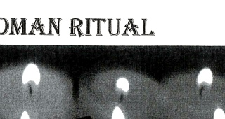
Roman Ritual devotional image from the original pamphlet
This section refers to sacramentals and blessings traditionally associated with the Roman Ritual. Where the Church reserves a blessing to a priest, the priest gives that blessing. Lay pilgrims use sacramentals with faith, reverence and obedience, never as magic objects and never as a substitute for the sacraments.

Sacramentals Mentioned
- Salt
- Water
- Oil
- Candles
- Rosaries
- St Benedict medals
- Miraculous medals
- Brown scapulars
- Other objects blessed for devotional use where permitted by the Church

Clarified Summary
The blessings ask God to make these sacramentals signs of faith, protection and devotion. Their purpose is to lead the pilgrim more deeply to Christ: repentance, prayer, trust, charity and obedience to the Church.

Final Pilgrim Reflection
A pilgrimage is not only a journey to a holy place. It is a journey back to God. Its fruit should be conversion: Confession, prayer, forgiveness, humility, worship, charity and a renewed willingness to follow Jesus with Mary’s help.
Immaculate Heart of Mary, lead us to Jesus. Sacred Heart of Jesus, have mercy on us. Holy Spirit, renew us. Amen.

Source Note
The Mass explanation in this draft has been aligned with the General Instruction of the Roman Missal, the Catechism of the Catholic Church, and the ordinary structure of the Roman Rite. It is included to support Father Charbel's emphasis on helping pilgrims understand the Mass step by step.
Key references: General Instruction of the Roman Missal, nos. 27-90 and 337; Catechism of the Catholic Church, nos. 1324-1327; USCCB, Order of Mass and Structure and Meaning of the Mass.

